<Revenant>

Game Concept Document

GAM100F15KR

By <Peekaboo>

Team Roster: HeeJae_Kwon, JongHeon_Kim.

<High Concept>

It is a 2D action, player-versus-player fighting game. Each player plays their chracter and use their character’s skills to defeat other player’s character.

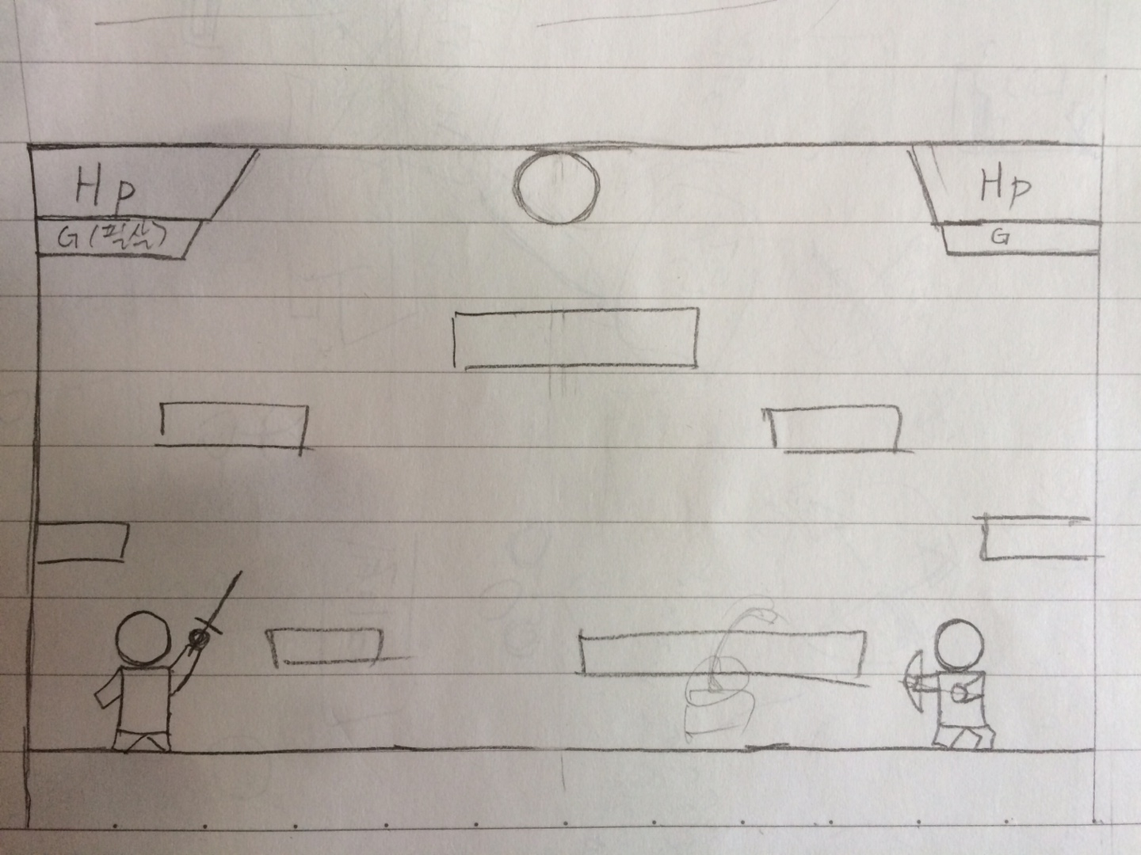

<Summary>

Each player plays their characters called ‘Revenant’, a visible ghost or animated corpse that was believed to return from the grave to terrorize the living, and fights with each other’s revenant to win for their revenant’s reincarnation.

<Game Mechanics>

Two players control their character with movement keys, attack key and defence key in one keyboard. Players can use some skills by combination of those keys. They have their own HP and one of two characters HP is 0, that character dies and that player will lose.

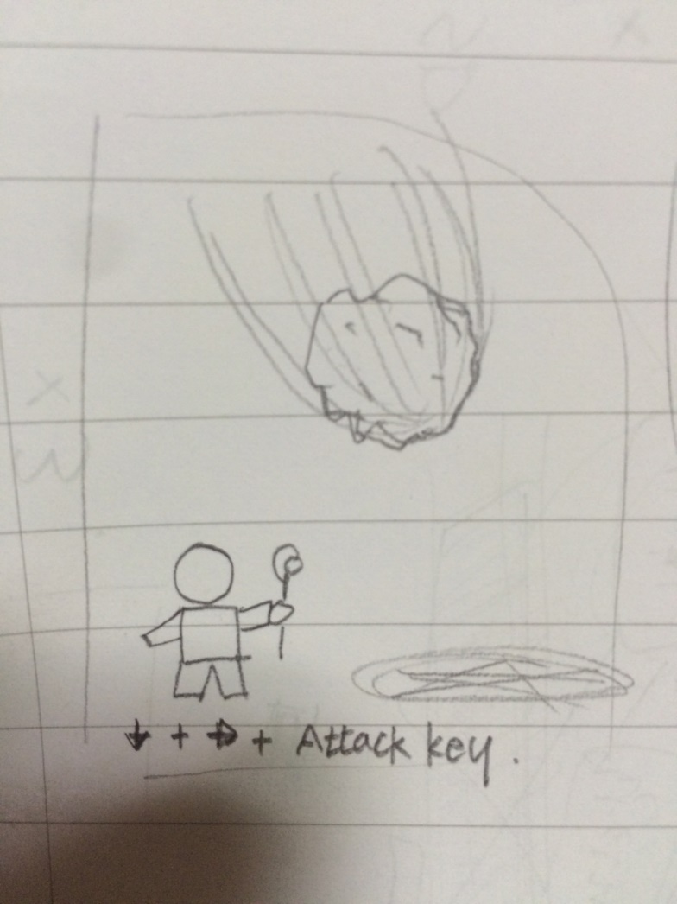

<Characters>

Characters have own skills like shooting the fireballs, laser beams, summoning some structures, or enhance their weapon.

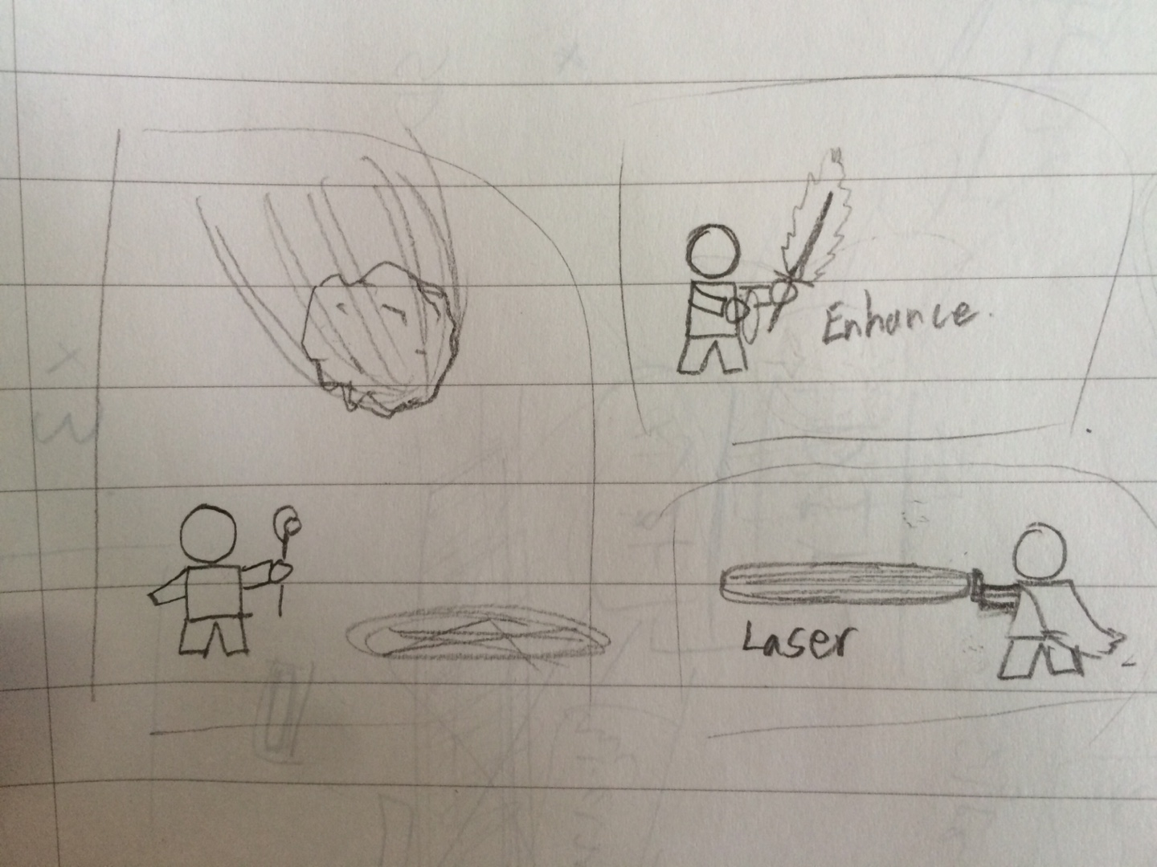

<Environment>

There are several maps like simple basic flat field map with some obstacles, or magma map that if character fall into the magma, their HP will reduce.

<Citations>

Do it ourselves.